1. Update the repositories

sudo apt update

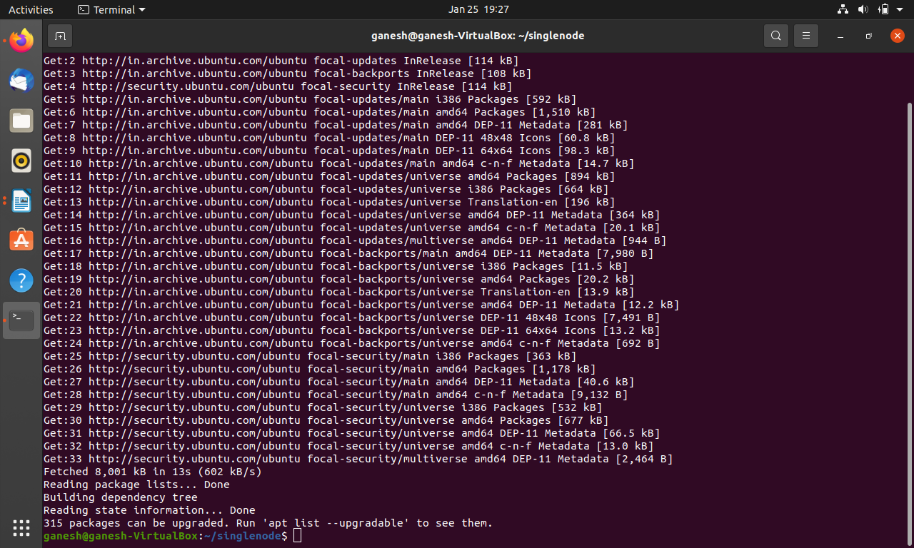

2. Download the geth 1.10.8 stable file(.tar.gz)( use the lates version)

3. Example: extract it using

sudo tar -xvf geth-alltools-linux-amd64-1.10.8-26675454.tar.gz

4. Step into extracted folder

cd geth-alltools-linux-amd64-1.10.8-26675454

5. It should contain the geth file, make it executable with the below command.

sudo chmod +x geth

6. Copy file to the user bin.

sudo cp geth /usr/local/bin/

cd ..

7. Check the Geth version with the following command

geth version

->Version: 1.8.16-stable

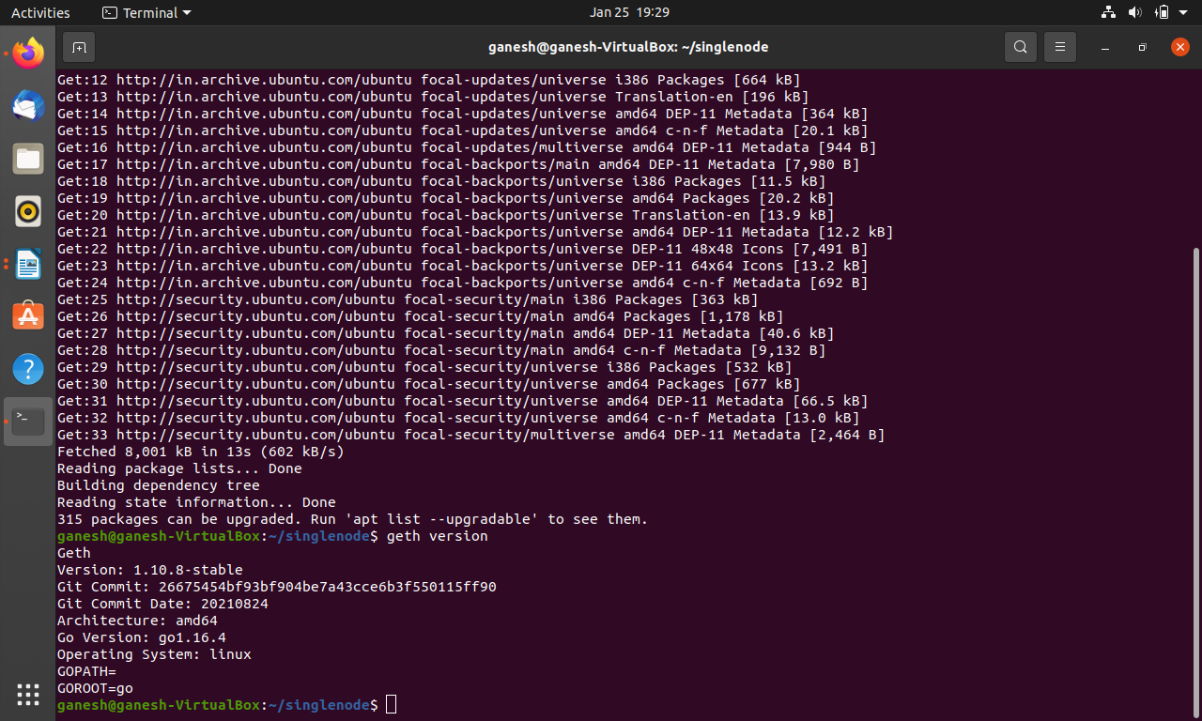

8. Make a directory

mkdir singlenode

9. go to that directory

cd singlenode

10. create a genesis file (gedit genesis.json)

{

"config": {

"chainId": 4321,

"homesteadBlock": 0,

"eip150Block": 0,

"eip155Block": 0,

"eip158Block": 0,

"byzantiumBlock": 0,

"constantinopleBlock": 0

},"alloc": {},

"difficulty" : "0x20000",

"gasLimit" : "0x8880000"

}

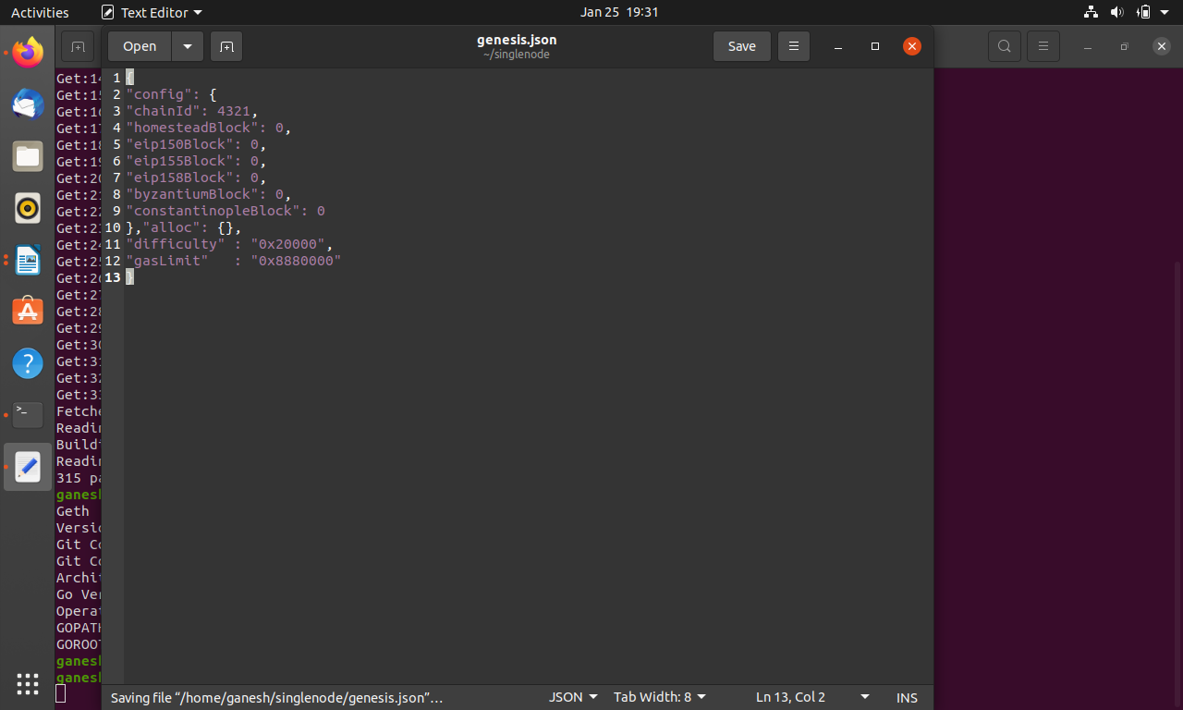

11. Create a directory for a node(node 1)

mkdir node1

12. Initialize genesis to that node using

geth --datadir node1 init genesis.json

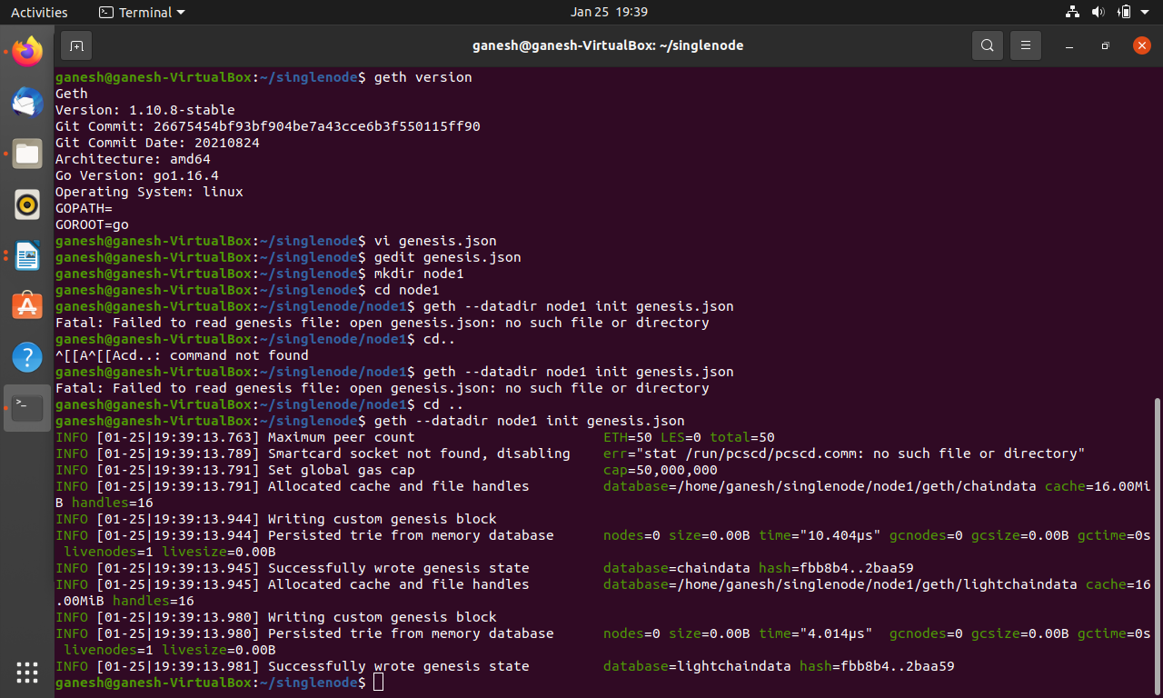

13. Now start the node using

**geth --http --http.corsdomain http://remix.ethereum.org --allow-insecure-unlock --http --http.port 8545 --http.addr 127.0.0.1 --http.corsdomain "*" --http.api "eth,net,web3,personal,miner" --datadir node1 --nodiscover --networkid 4321 --port 30303 console –rpc.enabledeprecatedpersonal**

**0r**

**geth --http --http.corsdomain http://remix.ethereum.org --allow-insecure-unlock --http --http.port 8545 --http.addr 127.0.0.1 --http.corsdomain "*" --http.api "eth,net,web3,personal,miner" --datadir node1 --nodiscover --networkid 4321 --port 30303 console –rpc.enabledeprecatedpersonal –ipcdisable console**

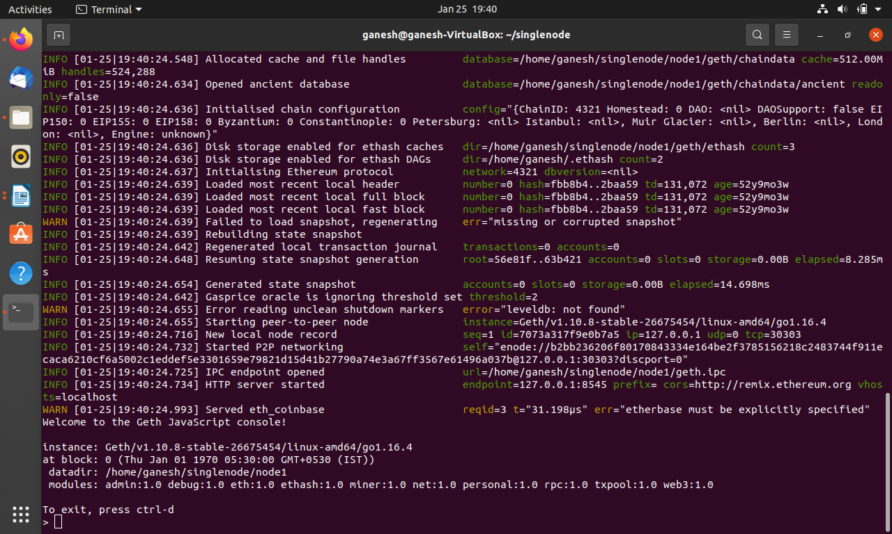

14. now create first account in the node

personal.newAccount()

14*. now create second account in the node

personal.newAccount()

15. set a password

eth.accounts

["0x6e3f9fff3bd1a221f949d6ff320f2fe720daded5", "0x1b7d8c6763bcd39aa3bb8dfedd0fa992d6a3b2e2"]

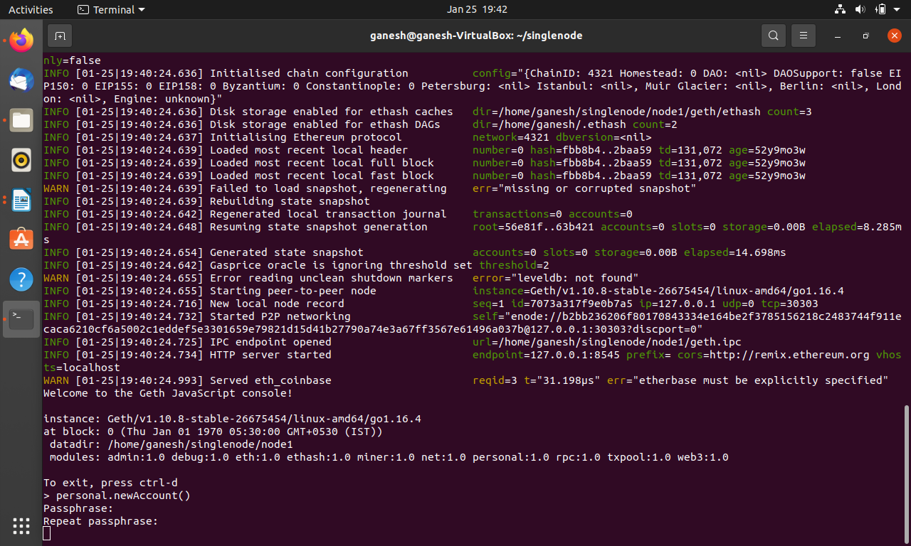

16. set the miner to the first account

miner.setEtherbase(eth.accounts[0])

17. start the miner.Here miner started with 1 thread. With 1 thread it is slow. We can also start with

4 threads.

miner.start(1)

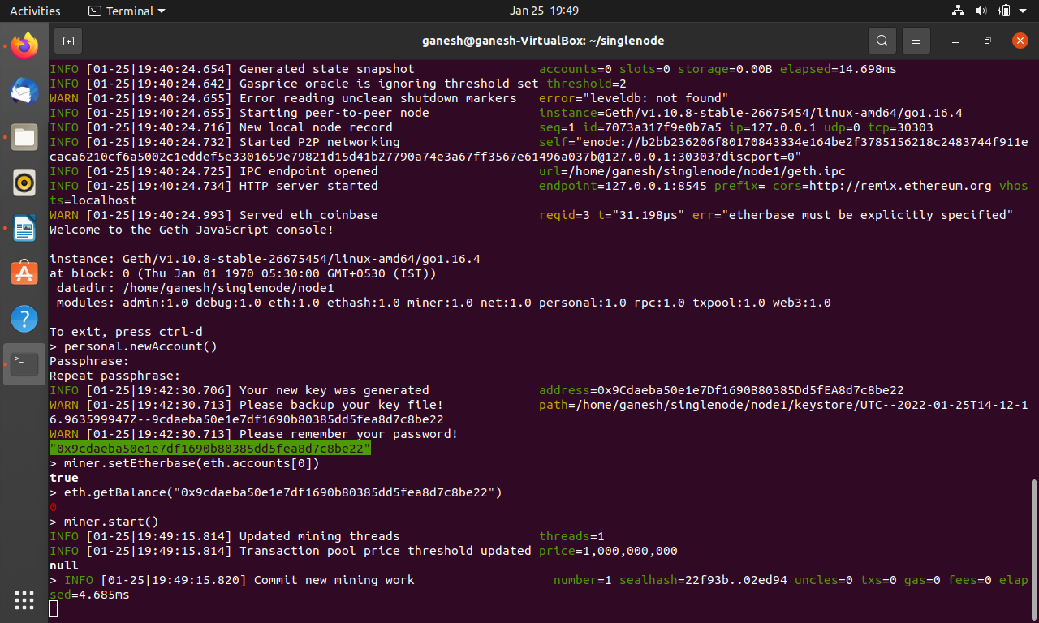

18.stop the miner after mining potential block \\wait for some time before stopping miner

miner.stop()

19. check the balance using

eth.getBalance(eth.accounts[0])

20.set the miner to the second account

miner.setEtherbase(eth.accounts[1])

21. start the miner.Here miner started with 1 thread. With 1 thread it is slow. We can also start with

4 threads.

miner.start(1)

22.stop the miner after mining potential block \\wait for some time before stopping miner

miner.stop()

23. check the balance using

eth.getBalance(eth.accounts[1])

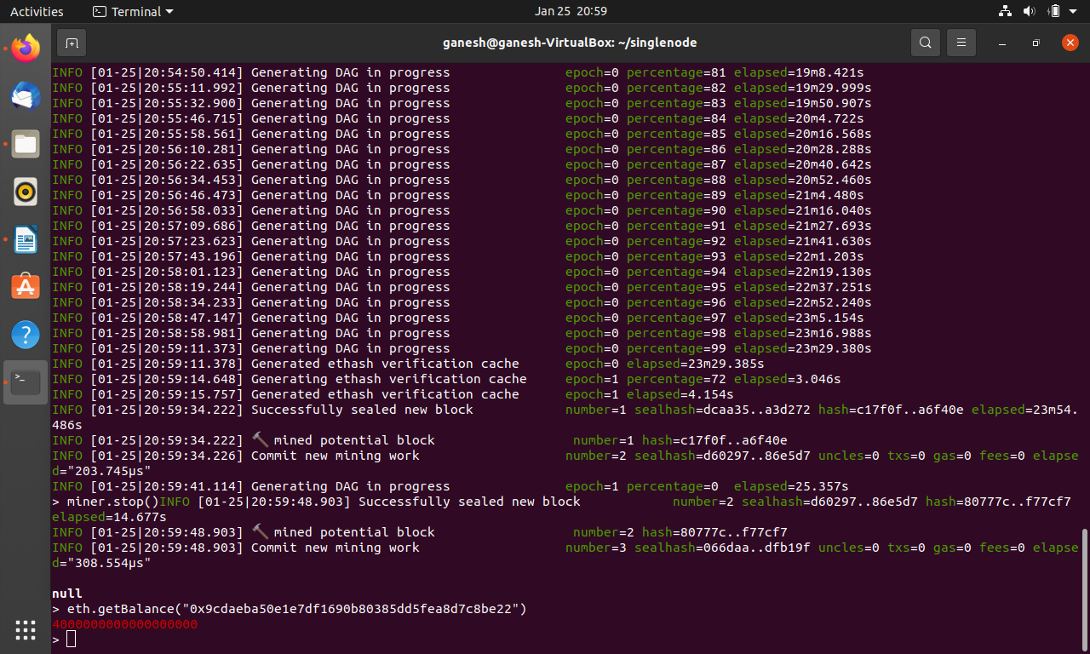

24. Unlock the account from which you want to send funds, to perform the transaction from that account. Here in below last parameter 600 specifies the in seconds for unlock duration.

web3.personal.unlockAccount(web3.personal.listAccounts[0], null, 6000)

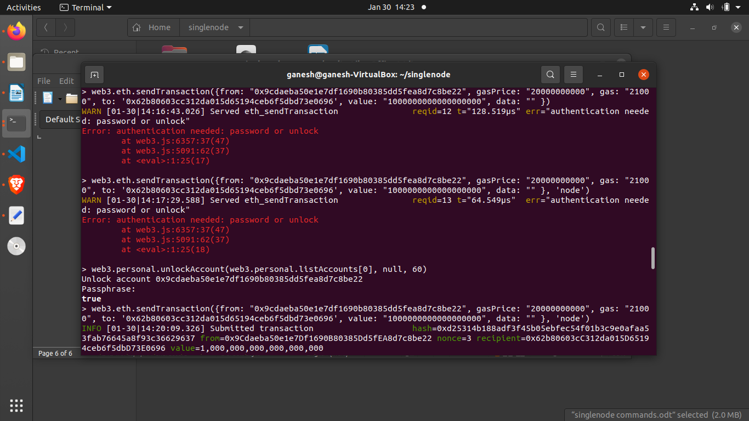

25. Now send the funds using

eth.sendTransaction({from: "0xcd877363343ae452b6de80b460711fdc56ec2eb7",to: "0x2907068a1836394d1ae345124dbb10dccbf3a0d7", value: "74000000"})

or

eth.sendTransaction({from: eth.accounts[0],to: eth.accounts[1],value: "74000000"})

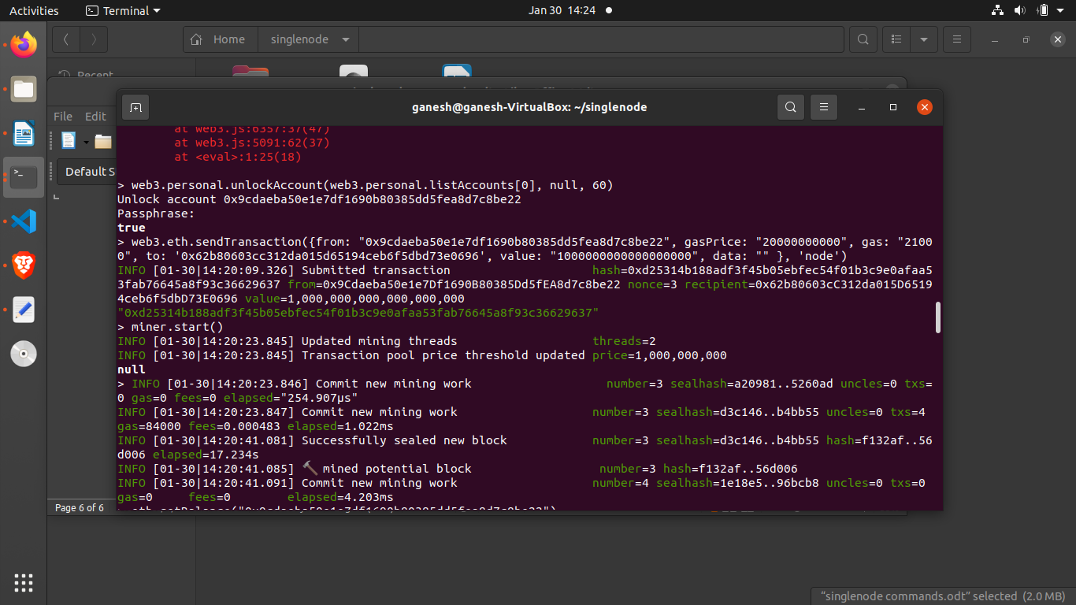

26. Now start the miner

miner.start(1)

27. Stop the miner after it has mined an block and check the balance

miner.stop()

eth.getBalance("0x62b80603cc312da015d65194ceb6f5dbd73e0696")

Updated Balance from 0 to 1114000000000004000

